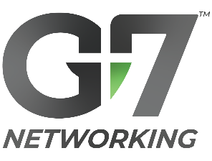
Scripts for Guest Follow-up
Why? Timely follow-up dramatically increases your chance of success in getting a new referral partner!
Last updated: 10.10.2022

Step #1 | SAME DAY: Thank you call + email

Subject: Thank you for visiting our G7 chapter!

Hello [ Name of Guest ],

[ Intro statement, e.g. Per my voicemail… ]. Thank you for being a guest of [ Chapter Name, e.g. G7 Minneapolis ] today. Say, while it’s fresh in your mind, could we schedule a 15-min phone/Zoom discussion within the next day or two please?

My purpose:
- Thank you
- Seek to understand your guest experience & any advice you have for us please?
- Answer any questions you may have about G7 Networking with Purpose.

Would you be able to take my call within one of my current available openings please?
[ List your available dates/times. ]
Other?

Here is a link to our chapter website:
[ Add the chapter’s website link here. ]

Thanks for your kindness and direction.

Be encouraged,
[ Your Signature ]

Step #2 | Within 1-2 Days: Follow-up Zoom / Phone Call

Meeting Outline (15 min):
  - Thanks for attending!
  - Any guest experience comments/advice for us?
  - I’m here to answer any questions you may have.
  - On a scale of 1-10 (with 10 = high), do you think this would be a vehicle to help you grow your business?
  - If 8–10, invite into G7 courtesy membership + next G7 Event. Help them do it NOW, either w/ your chapter website or g7networking.com > “Try before You Buy”.
(If they decline, ask to schedule time to do this within next couple days.)

