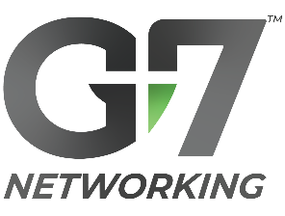
LinkedIn Chapter Booster

Outcome: | With a little bit of coordination, the LinkedIn Chapter Booster goes a long way towards enhancing your chapter’s visibility & getting more guests at your next chapter event.
Strategy: | - Each week, 1 designated point-person creates a LinkedIn post & reminds the chapter.  - All other chapter members maximize that post’s reach by commenting, re-sharing, & inviting their own LinkedIn connections.
Please note: Social media is no substitute for personal invitations!
During this coordinated effort, call, text, or email your colleagues to your event.

3 Weeks Before Event — Event Announcement
🕑 Time to Complete = 30 min

Event Image | 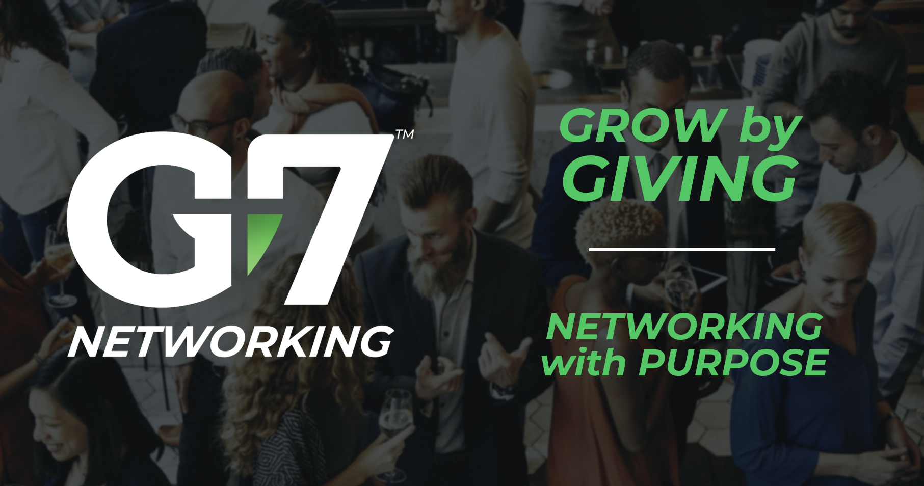
Description | G7 is a trust-centered, networking organization, driving new business for members through teams of local referral partners. Together, we connect Christians and all business professionals to exchange warm leads while growing in all areas of life.  Come & experience a networking group that prioritizes people!  Visit our next chapter event! — Insert chapter website link  Learn more about G7 — www.g7networking.com/what-is-g7

Step-by-Step for “3 Weeks Before Event” Booster:
- On the Event Image above, right-click on the image, click “Save as picture”, & save to any location on your computer.
- Customize the “Description” text above with your own voice.
  - Do one final spelling/grammar check!
- Insert your chapter website link into the Event Description.
(continued on next page)
  - Go to https://app.g7networking.com/find-chapter
  - Find and select your chapter. Click “Learn more about this chapter”.
  - Copy the web address from the top of your browser and paste it into the designated area of the Event Description.
  - Pro Tip: It’s a GREAT idea to bookmark your chapter website page in your browser for easy sharing!
- Sign into https://www.linkedin.com/login
- In the new post area, find & click “Event”, and create event with these settings:
(Pro Tip: Open the event in the G7 App for reference!)
- Event Type: | In person
- Event Name: | G7 Chapter Name/Location Business Networking Event (e.g. G7 Chicago Business Networking Event)
- Start & end: | Enter scheduled dates & times.
- Address/venue: | Enter appointed address/suite #.
- External event link: | Insert chapter website link
- Description: | Copy-paste “Description Text” above.
- Speakers: | Tag all chapter leaders.
- Then, click “Next”
- When brought to the “Share” window, create a post with these settings:
- “What do you want to talk about?” area: | Copy-paste the same “Description Text” above.  Underneath the pasted text, use the @ symbol to tag your other chapter members.
- Add hashtags: | Add any hashtags you like.
- Speakers: | Tag all chapter leaders.
  - Click “Post”
- Invite your own business connections to this event. Target individuals w/ business categories open in your chapter & from which you get new business!
- Immediately, copy the web address of the LinkedIn event from the URL-address bar in your browser. Paste into designated area of message below. Email or text this to your fellow members:
Reminder Message | Hello my fellow G7 Members,  Today our G7 event was posted on LinkedIn!  Insert LinkedIn Event link  Remember to comment, reshare, and invite colleagues among your own LinkedIn connections!

To download the other LinkedIn Booster posts
go to: https://www.g7networking.com/blog/linkedinbooster

