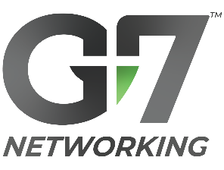
Member Meetup Notes
Time, Date | Member(s)
Desired Outcomes: Get to know one another personally, professionally, & spiritually. Build trust. Discover ways to support one another.
Watch tutorial for meetup prep, execution & follow-up:
https://www.g7networking.com/blog/member-meetups-build-trust
(In advance: Connect on LinkedIn. Research questions & connections below.)
Meetup Outline
- Open in prayer.
    - Ask God to guide the conversation.
- Ask personal background questions. (Alternate asking/listening).
Use these or come up with your own!
    - Current Role: how’d you find it?

    - Top 3 priorities in life?

    - Enjoy what when not working?

- Ask pertinent business questions. (Alternate asking/listening).
    - Overview of business?

    - Key differentiators?

    - Why should my network work with you?

- Present opportunities for support.
  - My connections that might benefit G7 Member

  - ID’ed connections as ideal referral examples for me

  - Other ways to support?

